Welcome to SautinSoft!

This is «RTF to HTML .Net» sample
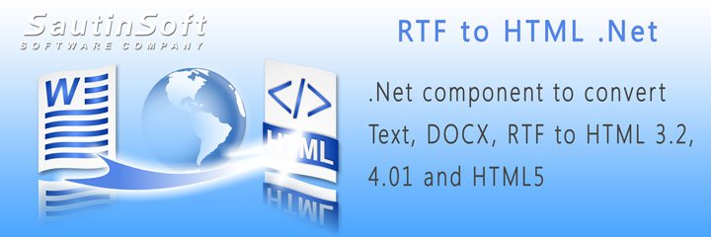
Subtitle
This rich text document content serves as basis for trying out various rich text formatting.

Header 1
Bold italic underlined strikethrough N_{subscript} N^{superscript}

Sub header 1.1
Fonts:
Times new roman
Arial
Courrier
Verdana
Tahoma

Heading level 3 (1.1.1)

Background testing
Foreground testing
A combination of both

Heading level 4 (1.1.2.1)

Ordered list of Popular web fonts
- Gotham
- Museo Sans
- Futura

Heading level 5 (1.1.2.1.1)

Multi-level
- A
  - A1
    - A.1.1

Heading level 5 (1.1.2.1.2)
Bullet lists
- fonts (family, size)
- bold,
- italic

Heading level 4 (1.1.2.2)
- A
  - A1
    - A.1.1

Heading level 3 (1.2.2)

TABLES
A | B | C | D
E | F | G | H
I | J | K | L
M | N | O | P

A | B | C | D
E | F | G | H
I | J | K | L
M | N | O | P

A | B | C | D
E | F | G | H
I | J | K | L
M | N | O | P

A | B | C | D
E | F | G | H
I | J | K | L
M | N | O | P

A | B | C | D
E | F | G | H
I | J | K | L
M | N | O | P

A Testing testing testing testing | B Testing testing testing testing | C Testing testing testing testing | D Testing testing testing testing
E Testing testing testing testing | F Testing testing testing testing | G Testing testing testing testing | H Testing testing testing testing
I Testing testing testing testing | J Testing testing testing testing | K Testing testing testing testing | L Testing testing testing testing
M Testing testing testing testing | N Testing testing testing testing | O Testing testing testing testing | P Testing testing testing testing

A | B | C | D
E | F | G | H
I | J | K | L
M | N | O | P

Heading level 4 (1.2.2.1)
Lorem ipsum dolor sit amet, consectetuer adipiscing elit. Maecenas porttitor congue massa. Fusce posuere, magna sed pulvinar ultricies, purus lectus malesuada libero, sit amet commodo magna eros quis urna.
Nunc viverra imperdiet enim. Fusce est. Vivamus a tellus.
Pellentesque habitant morbi tristique senectus et netus et malesuada fames ac turpis egestas. Proin pharetra nonummy pede. Mauris et orci.
Lorem ipsum dolor sit amet, consectetuer adipiscing elit. Maecenas porttitor congue massa. Fusce posuere, magna sed pulvinar ultricies, purus lectus malesuada libero, sit amet commodo magna eros quis urna.

